ACKNOWLEDGEMENT
We are extremely grateful and remain indebted to our guide MR. RAJINDER KUMAR CHITORIA for being a source of inspiration and for his constant support in the Design, Implementation and Evaluation of the project. I am thankful to him for their constant constructive criticism and invaluable suggestions, which benefited us a lot while developing the project on “LIBRARY AUTOMATION SYSTEM”. She has been a constant source of inspiration and motivation for hard work. She has been very co-operative throughout this project work. Through this column, it would be our utmost pleasure to express our warm thanks to her for their encouragement, co-operation and consent without which we mightn’t be able to accomplish this project.
We also express our gratitude to Mr. Rajinder Kumar Chitoria for providing us the infrastructure to carry out the project and to all staff members who were directly and indirectly instrument in enabling us to stay committed for the project.
BABLI KUMARI

PREFACE

This project of “LIBRARY AUTOMATION SYSTEM” of gives us the complete information about the library. We can enter the record of new books and retrieve the details of books available in the library. We can issue the books to the students and maintain their records and can also check how many books are issued and stock available in the library. In this project we can maintain the late fine of students who returns the issued books after the due date.
Throughout the project the focus has been on presenting information and comments in an easy and intelligible manner. The project is very useful for those who want to know about Library Automation System.
In the last, we gratefully acknowledge and express our gratitude to all staff members of PRS Computer and friends who supported us in preparing this project
COMPANY PROFILE
HCL Info systems Ltd are one of the pioneers in the Indian IT market, with its origins in 1976. For over quarter of a century, we have developed and implemented solutions for multiple market segments, across a range of technologies in India. We have been in the forefront in introducing new technologies and solutions.
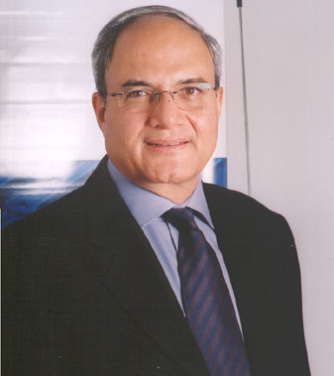
CHAIRMAN & CEO'S PROFILE
Ajai Chowdhry
Chairman and CEO, HCL Infosystems Ltd.
An engineer by training, Ajai Chowdhry is one of the six founder members of HCL, India's premier IT enterprise. HCL, a start-up in 1976, touched Rs.11, 000 crores for the last 12 months.
Ajai Chowdhry took over the reins of HCL Infosystems, the flagship company of the group, as President and CEO in 1994. He was appointed the Chairman of HCL Infosystems in November 1999. Under his stewardship, the company's turnover has grown to Rs.7783.6 crores in 2004-05 from Rs.400.6 crores in 1994. With employee strength of over 3600, it has emerged as country's leading information-enabling powerhouse.
Ajai has been a key force in driving the growth of HCL Infosystems. The credit of setting up HCL's overseas operations, starting with Singapore in 1980, goes to him. During this tenure he extensively covered South Asian Markets including Malaysia, Thailand, Hong Kong, Indonesia, and the People's Republic of China, expanding business operations, which paved the way towards enhancing HCL's core competencies in bringing the best international technologies to domestic market.
Driving the thrust on IT, Telecom and Imaging, Ajai perceives the role of his company as that of enabling information. Credited with providing momentum to key IT phenomena - within the company as well as in the industry - he has constantly added newer and cutting edge technology skills to the company's portfolio. Under his leadership, several new projects have been undertaken in the company that have had a lasting impact - getting into IT retailing, spearheading the company wide Quality movement, and the very recent low cost PC initiative and IT for masses are some examples. An absolute stickler for customer focus, he himself spends significant time, personally listening to customers.
Ajai sensed an emerging opportunity early in telecom and imaging category and today HCL Infosystems is poised to exploit this opportunity to offer a richer bouquet to its customers.
It is a recognition of his visionary status that Ajai was part of the IT Hardware Task Force, set up by the Prime Minister of India to give shape to the country's IT strategy. Ajai has repeatedly championed the cause of improving PC penetration in the country. He has worked closely with many Government bodies to take IT for masses agenda forward. Presently he is part of several government committees to take forward the course of IT and Hardware in India. He was awarded with 'IT Man of the Year' by The Skoch Consultancy and 'Best IT Man of the Year' by The Foundation of Indian Industry and Economists. Ajai also addressed CII's flagship hardware event 'India e-Hardware Summit 2004' at Hyderabad as a keynote speaker recently.Ajai has a bachelor's degree in electronics and communication engineering, and attended the Executive Program at the School of Business Administration at the University of Michigan, US.Ajai is an avid reader and is fond of Jazz and the fine arts. He and his wife Gita live in New Delhi.
2001
- Launched Pentium IV PCs at below Rs. 40,000.
- IDC rated HCL Info systems as No. 1 Desktop PC Company of 2001.
2002
- Declared as Top PC Vendor by Dataquest.
- HCL Info systems & Sun Microsystems enter into a Enterprise Distribution Agreement.
- Realigns businesses, increasing focus on domestic IT, Communications & Imaging products, solutions & related services.
2003
- Became the first vendor to register sales of 50,000 PCs in a quarter.
- First Indian company to be numerous undo in the commercial PC market.
- Enters into partnership with AMD.
- Launched Home PC for Rs. 19,999.
- HCL Info systems' Info Structure Services Division received ISO 9001:2000 certification.
- Launches Infiniti Mobile Desktops on Intel Platform.
- Launched Infiniti PCs, Workstations & Servers on AMD platform.
2004
- Ist announces PC price cut in India, post duty reduction, offers Ezeebee at Rs. 17990.
- IDC India-DQ Customer Satisfaction Audit rates HCL as No. 1 Brand in Desktop PCs.
- Maintains No. 1 position in the Desktop PC segment for year 2003.
- Enters into partnership with Port Wise to support & distribute security & VPN solutions in India.
- Partners with Microsoft & Intel to launch Beanstalk Neo PC.
- Becomes the 1st company to cross 1 lac unit milestone in the Indian Desktop PC market
- Partners with Union Bank to make PCs more affordable, introduces lowest ever EMI for PC in India.
- Launched RP2 systems to overcome power problem for PC users.

LIBRARY AUTOMATION SYSTEM
CONTENTS

1. | Project: An Introduction
 | - Summary
 | - Need of Project
2. | Objective
3. | Requirement Analysis
4. | Hardware and Software Specifications
5. | A Word About Visual Basic
6. | Existing System
7. | Work Done During the Project
8. | Design
9.  10. | Data Flow Diagrams  Project Layout
11. | Database
12. | Benefits
13. | Further Improvement
14. | Coding
15. | Bibliography
INTRODUCTION

SUMMARY

LIBRARY automation SYSTEM is software, which replaces the existing manual system into computerized format.

The screen of our project given as under-

“LIBRARY AUTOMATION SYSTEM”

The project is handled to me during my B.Tech VIIth Sem. was to LIBRARY automation SYSTEM. So, this project is for issuing of card developed in visual basic 6.0, with MS Access at the back end. It is an attempt to retrieve the burden of manual system by providing a user & manager with user friendly, fully automated and a secure system.

In the initial stage of my project I was to properly understand the concept of V.B 6.0 and proper scheduling which was done with the help of my coordinator. I was very deeply made to analyze about the project and at many times I was given sufficient lecture about the project.

NEED OF PROJECT

- Time saving: - Using computers can save a lot of time. This is possible, as computers are fast, efficient and more accurate as compared to human beings.

- Quick Reports: - A computerized system can help on generating different types of reports. This can be done easily by merely pressing few keys. Reports can be easily obtained at the spur of the moment unlike a manual system.

- Much More Details Available: - A large amount of details can be obtained easily in a computerized system which otherwise can’t be available in a manual system.

- Efficient and accurate: - Computerization will increase the efficiency and accuracy of the telephone department in maintains telephone directory.

- Faster and Easier Data Retrieval: - By using computerized system data can be retrieved at much faster pace. Old records can be located immediately and easily.

- Economical: - Due to computerization more accurate functioning can be obtained as compared to manual systems in long term.

- Decreased Number of People: - Computerization will decrease manpower dependence. It will decrease the number of people required for purchasing & selling goods.

PROCESS DESCRIPTION
The LIBRARY automation SYSTEM is designed & developed for a receipt and issuance of books in the library along with the student’s details. The books received in the library are entered in Books Entry form and the new student is entered in the student entry form. When the student wants to get the desired book the same is issued on the availability basis to the student. The issuance and due date for the returning of the book is also entered into the Book Issue form under third menu Book Issue. The student has to pay the fine if any on the basis of no. of days delayed deposit of the book in the library.
OBJECTIVES
Visual Basic has following objectives:
- Provide facility to spend more time on mastering the application and less time worrying about which keystrokes to what within menu and dialog boxes

- To provide programmer to have long had mixed feelings about LIBRARY automation SYSTEM.

- The objectives is to remove the headache of the programmer that what the mouse was doing, where the user was inside a menu, and whether he or she was clicking or double clicking at a given place.

- To provide perfect programming environment.

- It helps us to create effective and robust application packed with impressive outlook in minimum time.

- The main objective of Visual Basic is to provide an integrated development environment IDE.

- Another objective is to provide graphics programming.

DIGRAMMATIC REPRESTATION OF SDLC

Impetus for change
Recognition of need
Feasibility study
Analysis

Design

Implementation

Post-implementation

Maintenance

Sources of system ideas
Environment based
Organization based
Govt. rules and regulation
Organization
Impetus for change
Recognition of need
Feasibility study
Analysis

Design

Implementation

Post-implementation

Maintenance

Union

Competition

Consumers

Top Management

User

System Analyst

STEPS IN SYSTEM DESIGN:

Design submitted for approval
Design accepted?
2
Cost justification
Abandon project
1
Detailed system documentation
Yes
Go to implementation
Test program
Input design
Out of design
File design
Processing design
No
SYSTEM ANALYSIS
Software is always a part of large system. Work beginning by establishing requirements for all system elements and then allocating some subset by their requirements of software. This system view is essential, when software must interface with other elements such as hardware, people and database. Engineering and analysis encompasses requirement gathering of the system level with a small amount of top - level design and analysis.

The requirement gathering process is intensified and focusing especially on the software to understand the nature of the programs to be built, the software engineering, must understand the information domain for the software as well as the required functions, performance and interfaces. Requirement for both the system and the software are documented and viewed to the customer. A requirement baseline report is to be prepared for type of function.
Requirements for the Project:

- The project must accommodate the new requirements specified by the end user.
- The project must allow the user to take hard copy of the data.
- The project must provide a graphical view of the data for the corresponding month & year.
- The project must be easy to use and simpler to understand i.e. it should have easy to use navigation tools with some sort of assistance (tool tip text) attached with them.
- Should serve almost all desires of the common user, i.e. must meet the basic requirement criteria for a good Data Retrieval, Manipulation & Storage System for a cooperative society.
FEASIBILITY STUDY

The main objective of feasibility study is to test the technical, operational, logical, and Economical feasibility of developing the computerized system. Many feasibility studies are disillusioning for both user and analysts. First, the study often presupposes that when the feasibility document is being prepared, the analyst is in a position to evaluate solution. Second most studies tend to overlook the confusion inherent in system development -the constraints and the assumed attitudes. The feasibility study conducted for this project involves following key considerations.

- Economic Feasibility

- Technical Feasibility

3) Behavioral Feasibility

ECONOMIC FEASIBILITY:

Economic analysis is the most frequently method for evaluating the effectiveness of a candidate system. This is also known as cost/benefit analysis. The procedure is to determine the benefits and savings that are expected from a candidate system and compare with the costs.

Student information, account information and much other information are very costly and without proper handling there is a probability of loosing them. This project is very easy to understand and user friendly. From this analysis we come to the conclusion that the total benefits exceeds the total cost invested in the project.

TECHNICAL FEASIBILITY

Technical feasibility centers around the exiting computer system and to what extent it can support the proposed addition. This involves financial considerations to accommodate technical enhancement. If the budget is a serious constraint, then the project is judged not feasible.

This project is feasible on the basis of technical consideration. This system handles large amount of data in an efficient manner.

BEHAVIORAL FEASIBILITY

In this analysis an estimate should be made of how strong a reaction the user is likely to have towards the development of the computerized system.

This developed computerized system will get support from the user side as it increases the handling of large amount of database.

STEPS IN FEASIBILITY STUDY

Feasibility analysis involves eight steps:

- Form a project team and appoint a project leader.

- Prepare flow charts.

- Enumerate potential candidate systems.

- Describe and identify characteristics of candidate systems.

- Determine and evaluate performance and cost effectiveness of each candidate system.

- Weight system performance and cost data.

- Select the best candidate system.

- Prepare and report final project directive to management.

NEED FOR COMPUTERISATION

Computerization of every department has reduced and over come the sort comings of existing system and to increase the efficiency to provide prompt and accurate service to the users.

ADVANTAGE OF COMPUTER OVER MANUAL SYSTEM

When size of organization grows, records also increased and have to be updated. Manually we can manage up to some limit but when the size of work increases it becomes a large problem. So this software helps reducing the problems.

FEASIBILITY STUDY

Depending on the result of initial investigation, the survey is expanded to a more detailed feasibility study. A feasibility study is a test of system proposal according to its workability, on the organization, ability to meet user needs, and effective use of resources. It focuses on three major questions:

- What are the user’s demonstrable needs and how does a candidate system meet them?

- What resources are available for given candidate systems? Is the problem worth solving?

- What are the likely impacts of the candidate system on the organization? How well does it fir within the organization’s master MIS plan?

Each of these questions must be answered carefully. They revolve around investigation and evaluation of the problem, identification and description of the candidate systems, specification of performance and the cost of each system, and final selection of the best system.

The scope of feasibility study is not to solve the problem but to acquire a sense of its scope. During the problem definition is crystallized and aspects of the problem to be included in the system are determined. Consequently, cost and benefits are estimated with greater accuracy at this stage.

The result of feasibility study is a formal proposal. This is simply a report – a formal document detailing the nature and scope of proposed solution. It consists of the following.

- Statement of problem- a carefully worded statement of problem that led to analysis.

- Summary of findings and recommendations- a list of major findings and recommendations of the study. It is ideal for the user who requires quick access to the results of the analysis of the system under study. Conclusions are stated, followed by list of recommendations and justification for them.

- Details of findings- an outline of methods and procedures undertaken by an existing system, followed by coverage of objective s and procedures of the candidate system. Included are also discussions of output reports, file structures, and costs and benefits of the candidate system.

- Recommendations and conclusions- specific recommendations regarding the candidate system, including personal assignment, costs, and project schedules, and target dates.

After the proposal is reviewed by management, it becomes a formal agreement that paves the way for actual design and implementation. This is crucial decision point in the life cycle. Many projects die here, whereas the more promising ones continue through implementation.

The final report prior to the implementation phase includes procedudural flowcharts, record layouts, report layouts, and a workable plan for implementing the candidate system. Information on personal, money, hardware, facilities, and their estimated cost must also be available. At this the project cost must be close to actual costs of implementation.

SOFTWARE REQUIREMENT
Front end : Visual Basic 6.0
Back end : Ms – Access
Operating System Support:
Platforms : Windows 9x/2000/NT, XP, UNIX, LINUX.
HARDWARE REQUIREMENT

HARDWARE USED:

The hardware’s specifications for this “LIBRARY automation SYSTEM System” software are as follows:

Specifications:
Space taken : This software hardly takes 500 kilo byte space on your disk.

Minimum System Requirements:
Processor : PIII or Higher with 1.8 GHZ.
RAM : 256 Mega Byte.
Display : 32 bit colors.
Hard Disk : 20 GB
Monitor : Color.

Design
System Design
The design is a solution and the translation of the requirement in to ways of meeting them. It is a “how to” approach for creation of a new system. It provides the understanding and the procedural details necessary for the implementation of the system. The design of an information system produces the details that state how a system will meet the requirements identified during the system analysis. It is stored by identifying reports and other outputs the system produced.

The system design also describes the data to be input, calculated or stored. Individual data items and calculation procedures are written in detail. File structure and storage devices are selected. It also includes the way the data is processed to produce the desired output. Design is responsible for providing programs with clearly outlined specifications that state what the software should do. As programming starts, System design is available to answer the question clarifying the fuzzy areas and handle problems that co-front the programming while implementing the design specifications.

Emphasis is on translation the performance requirement in to design specifications. Design goes Logical and Physical stage of development. Logical design reviews the present physical system. Prepare input and output specification: make edit and design walkthrough. The physical design maps out a detail of the physical system. System implementation and the device implementation plan.
Proposed Database
Access File
The MS Access file named in the format “proMonthYear.mdb” where month corresponds to the current month and the year corresponds to current year contains a table called “Main” that stores the entire data for a particular month. The file is generated automatically by the project in every month and named accordingly. But the data is retrieved from a temporary file “currecord.mdb” that is a copy of the current month’s file. Similarly a file named “prevrecord.mdb” is used as a temporary file to view previous records.

The MS Access file named in the format “card.mdb” where year corresponds to current year contains two tables called “Emp” & “Info”. The “Emp” table stores the name of the employees as well as their status i.e. they are still associated with the society or not. The “info” table keeps the CD record for each month of the corresponding year. The file is generated automatically by the project every year and named accordingly.

The MS Access file named “users.mdb” contains a table called “Formula” that is used to store the value for CD, OD and Interest and is manipulated to change the values of CD, OD & Interest.

For the authority and password we have used MS Access file named “level_status” as the database. The database for password maintains the User ID and the Password for each of the users.
Benefits
The following are the benefits of using the application:

Economical
The project is very cheap when compared to other commonly available Data Retrieval, Manipulation & Storage System for a cooperative society.
Easy to Master
The project provides a very friendly approach to its features, the look and appearance of each control is designed in such a way that only by viewing them the user can understand its functionality.
Easy to Use
The project provides the user an easy approach to its functionality by providing Toolbars that contains buttons for almost all required tasks. The user can easily navigate from one part of the project to another without having any sort of trouble.
Security
The project is divided into three measure applications: the Administrator, the User and the Guest, the Administrator is authorized for modification of data and can change Password for all the three levels; he can also change the values of CD, OD & Interest. The user can modify the data but can not change Password, CD, OD and Interest. The guest can only view the data but can not make any changes.
Reliability
The project is highly reliable because there is no chance of any loss of data and the data available can be altered only by the authorized users.

Time Saver
Data retrieval and storage using this system is much faster than maintaining the record manually.

DATA FLOW DIAGRAM

DATA FLOW DIAGRAM

When solving a small problem, the entire problem can be tackled at once. For solving larger problems, the basic principles the time-tested principle of “divide and conquer”. Clearly, dividing in such a manner that all the divisions have to be conquered together is not the intent of this wisdom. This principle, if elaborated, would mean, “divide into smaller pieces, so that each piece can be conquered separately”.
The DFD was first designed by Larry Constantine as a way of expressing system requirements in a graphical form; this led to a modular design.
A DFD, also known as “bubble chart,” has the purpose of clarifying system requirements and identifying major transformations that will become programs in system design. So it is the starting point of the design phase that functionally decomposes the requirement specifications down to the lowest level of detail. A DFD consists of series of bubbles joined by lines represent data flows in the system.
DFD SYMBOLS
In the DFD, there are four symbols.
- A square defines a source (originator) or destination of system data.
- An arrow identifies data flow- data in motion. It is a pipeline through which
information flows.
- A circle or a “bubble” (some people use an oval bubble) represents a
process that transforms incoming data flows(s) into outgoing data flow(s).
DATA FLOW DIAGRAM

Data flow diagram is a graphic tool. It is used to describe and analyze the movement of data through a system manual or computerize.

They focus on the data flowing into the system, between processes in
and out of the data stores.

The system models are termed as data flow diagram (DFD). A full description of system consists of a set of Dads, which compromises of various levels.

There are various levels of data flow diagram (DFD). The previous level of DFD can be broken down into a more detailed (DFD). This occurs repeatedly until sufficient detail (lowest level) is described to allow the analyst to fully understand that portion of system.

The various levels of data flow diagram (DFD) are as follows: -

- Physical Level DFD
- Logical Level DFD

Physical Level DFD:

The physical DFD is a model of current system and used to ensure that the current system has been clearly understood.

Physical DFDs show actual devices, departments, people etc. involved in the current system.

LOGICAL LEVEL DFD:

During the design activity of the proposed system this is taken as the basis for drawing the system.

Logical level DFDs are the models of proposed system. They should clearly show the requirements on which the should be built.

Finally the conclusion for the different levels of Dads we can say that both physical and logical Dads support a Top-Down Approach to system analysis. For this purpose, analysts begin by developing a general understanding of the system and gradually explode components in great detail. This achieved through the context diagram, first level DFD, second level DFD

DECISION ANALYSIS

Decision analysis focuses on the logic of the decisions that are made, or need to be made, within the organization to carry out the objective of the project.

Once all the process procedures are documented, the user to ensure accuracy should review the process procedures and logic.

There are three methods available for documenting and analyzing the logic of decisions including:

- Structure English
- Decision Trees
- Decision Tables

There are various conditions in a process. When all possible actions are known, the analyst must know what to do? And when to do?

Process can be broken into:

- Sequence of actions

- Selection of action based on some conditions

- Repetition of actions

STRUCTURED ENGLISH

Structured English is used when decisions are not very complex. This method makes use of narrative statements to describe a procedure.

Structured English specifications require the analyst to identify:

- The conditions that occur in a process

- The decisions that must be made when these conditions occur

- Action to be taken

Note: no symbols or formats are used. Entire procedures can be stated in English-like statements.

On whole Structured English consists of:

Structured logic or instructions organized into nested and grouped procedure.

Simple English statements such as add, multiply move, and so on.

DECISION TREE

A decision tree is a diagram that presents conditions sequentially Thus showing the order of conditions. This method shows the relationship of each condition and its permissible actions.

The diagram resembles branches of tree, hence called decision tree.

An open rectangle is a data store-data at rest, or a temporary repository of data.

MEANING COMMENT

= Source or destination May be one customer or number
Transaction of customer with (order)

= Data flow May be physically contained in a
Purchase order, invoice, phone,
Letter, etc.

= Process that transfer May be a clerk computing discount
Data flow or a procedure of manual
Computing.

= Data store can be a card file, a filing cabinet on disk etc.

DATA FLOW DIAGRAMS – BASIC SYMBOLS

User account number

registered
PROCESS
Account holder
CUSTOMER
INFORMATION FILE
User account number
Check
Invoice

CONSTRUCTING DFD

Several rules of thumb are used in drawing DFDs:
- Processes should be named and numbered for easy reference. Each name should be representative of the process.
- The direction of flow is from top to bottom and from left to right. Data traditionally flow from the source (upper left corner) to the destination (lower right corner), although they may flow back to a source. One way to indicate this is to draw a long flow line back to the source. An alternative way is to repeat the source symbol as a destination. Since it is used more than once in the DFD, it is marked with a short diagonal in the lower right corner
- When a process is exploded into lower-level details, they are numbered

O-LEVEL DFD
TO VERIFY APPLICATION USER

VALIDATION
VALIDATE USER
NAME AND
PASSWORD
LOGIN SUCCEEDED
USER
USER
MAIN MENU
VALIDATION FAILED
INVALID USER/ PASSWORD

      - LEVEL DFD OF THE SUB-MENU
CONTENTS OF MAIN MODULE
CONTENTS
MAIN MENU

DATA
INPUT DATA
EVENT
PROCESS
REGISTRATION

REGISTRATION SLIP PROCESSES

1-LEVEL OF THE SUB-MENU
PERSONAL DETAIL OF MAIN MODULE
USER
DETAIL
UPDATE RECORD
MAIN MENU

INPUT DATA EVENT INPUT DATA OF THE
ALLOTED APPLICANT
NEW RECORDS
ONLY

CONTENTS OF CONTENTS OF
APPLICANTS CO-APPLICANTS

PRIMARY DETAILS DOCUMENT CHECK LIST

2-LEVEL DFD OF THE WHOLE PROJECT
save
new

USER
INFORMATION
save
new

delete
REGISTRATION

STORE IN FILE
last
User
first
next
ACCOUNTS
DETAILS
save
new
delete
first
next
last
first
last
next
delete
Pusrchasing information
save
new
delete
first
next
previous
last

previous
previous

previous

ENTITY RELATIONSHIP DIAGRAM

ENTITY RELATIONSHIP DIAGRAM

Acc. NO
Library Management
.
Password

NAME
CONTENTS
User Acc. No.
PRIMARY
Purchasing item
APPLIC_FEASIBLE
USER FEASIBLE
USER FEASIBLE 1
P.NO.

HAS ADD. TO
PRIMARY
COLLEGE’S
USER
DETAIL
RECORD

OTHER INFORMATION.

COUNT
USER VERIFY WORK APP. DETAILS ARE
OR PAIR

CHECK
DETAILS

HAS NO &
User Acc. NO.

CAPACITY IS

OK

INCORRECT

Table description
bookdetails
serialno | bookname | publisher | numberofcopies | author | libraryid
3 | TCS | TMH | 10 | Martin | 103
5 | VB_IN_21_DAYS | Macmillan Computer Publishing | 10 | GREG PERRY | 105
2 | EDC | technova | 15 | Katre | 103
1 | bee | technova | 25 | shaikh | 101
4 | DCOM | technova | 25 | Katre | 104

daccounts
dealername | amountpaid | amountbal | totalamount
xyz | 1230 | 270 | 1500
abc | 2000 | 0 | 2000
lmn | 2966 | 34 | 3000

studentrecord
studentid | name | book1 | returndate1 | book2 | returndate2
101 | Deepak | TCS | 13-7-2006 | DCOM | 15-7-2006
102 | NIlesh | dbms | 11-7-2006
103 | Amit | microprocessor | 15-7-2006
104 | Jigar | EDC | 15-7-2006 | TCS | 18-7-2006

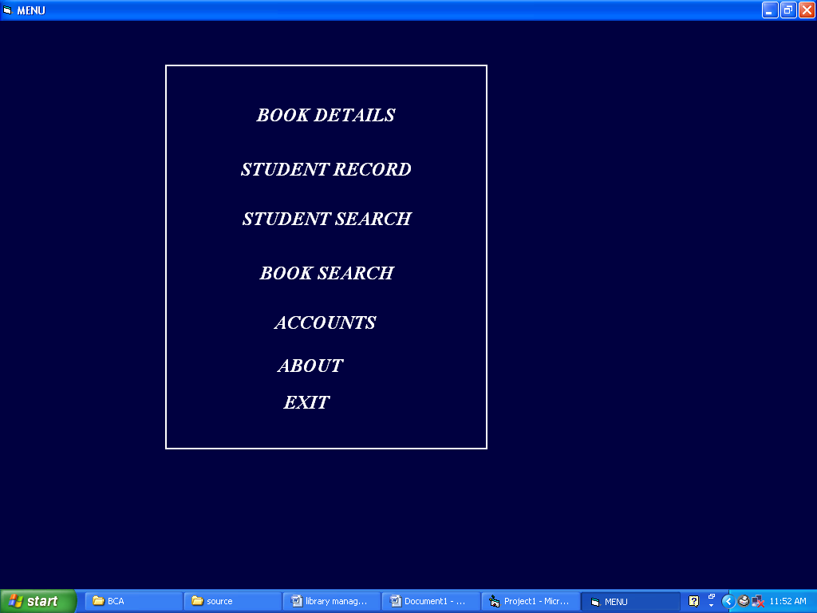
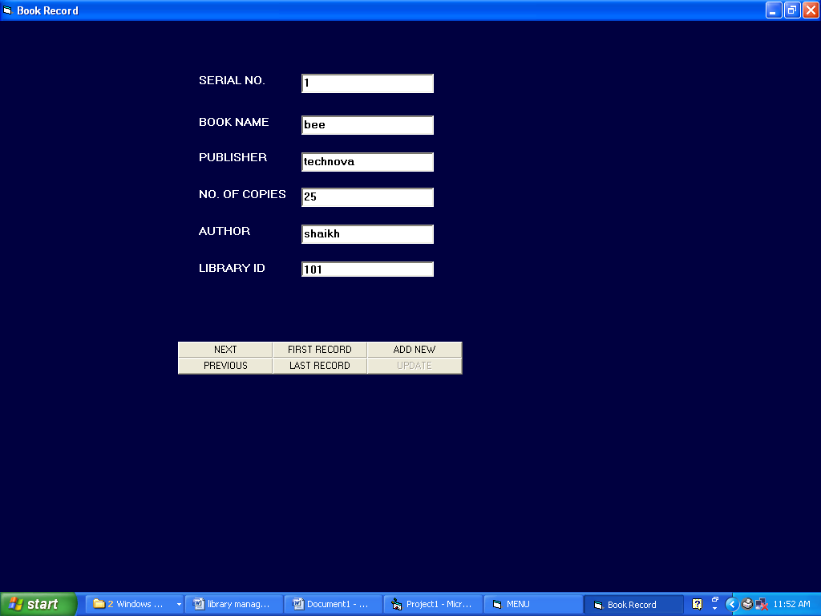
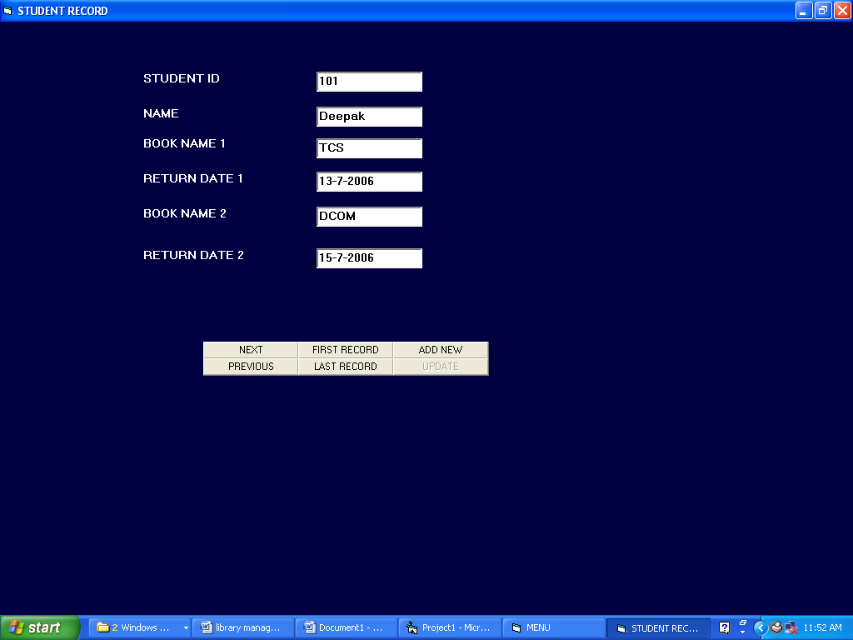
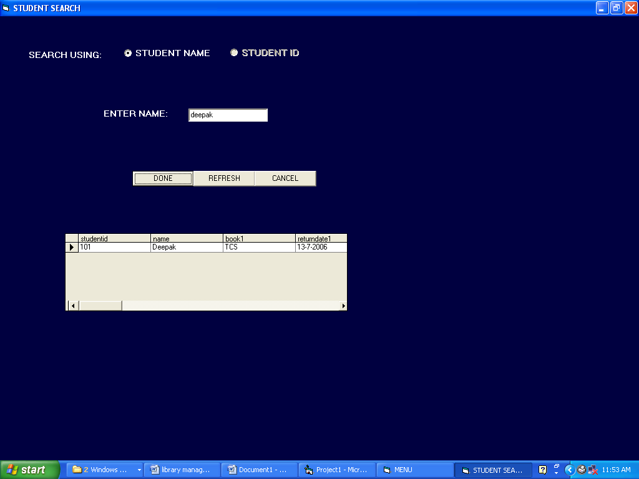
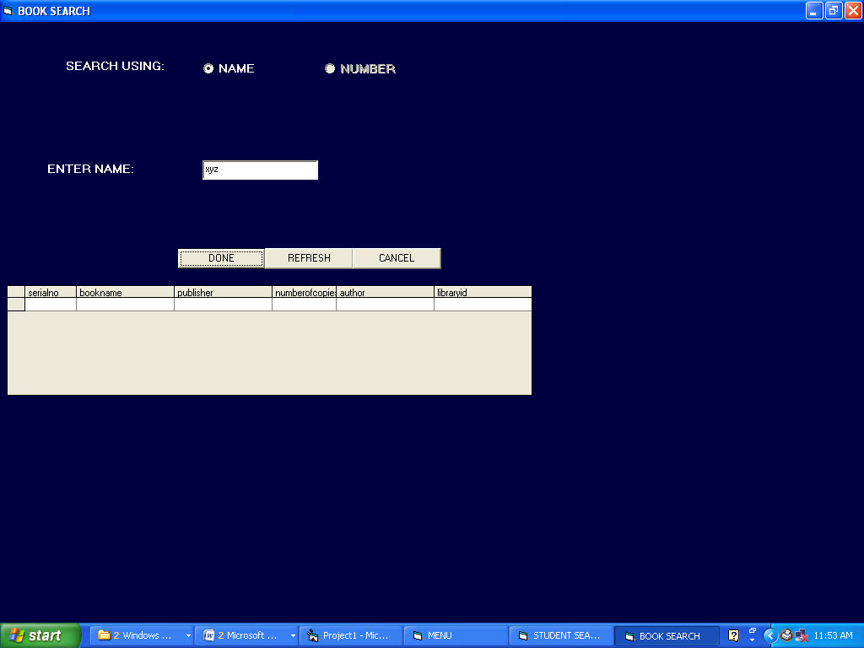
Testing

It is integral part of any system’s development life cycle without which the system developed is sure to fail and result in loss of economic and manpower investments besides user’s dissatisfaction and downfall of reputation.

System testing is the stage of implementation, which aims at ensuring that the system works accurately and efficiently before actual operation commences. No program or system design is perfect, communication between the user and the designer is not always complete or clear. All this can result in errors.

Another reason for system testing is its utility as a user oriented vehicle before implementation. The application system is worthless if does not meet user needs, thus the system should be tested to see whether it meets the user requirements.

Testing here is conducted in bottom up approach as follows:
- Module testing: Here testing is done at each module level. Each case has been throughly tested to discover pitfalls.
- System testing: Here testing is done after all the modules have been integrated.

IMPLEMENTATION

The implementation phase is less creative than system design. It is primarily concerned with user training, site preparation, and file conversion. During final testing, user acceptance is tested, followed by user training. Depending on the nature of system, extensive user training may be required. Conversion usually takes place at about the same time the user is being trained. Programming is ought to be a design work. The initial parameters of the candidate system should be modified as a result of programming efforts. Programming provides a “reality test” for the assumption made by analyst.

System testing checks the deadliness and accuracy of the system to access, update and retrieve data from new files. Once the programs become available, test data are read into the computer and processed against the files provided for testing. If successful, program is then run with “live “data. Otherwise a diagnostic test is used to locate and correct errors. In most conversion, a parallel run is conducted where the new system simultaneous run with old system. This method, through costly, provides added assurance against errors in the candidate system and also the user staff an opportunity to gain experience through operation.

FUTUREISTIC SCOPE

The future enhancement of the software can provide many more other facilities in the different areas like payroll, scheme human resources and development section of institute.

FURTHER IMPROVEMENTS

The further improvements can be done in project, are list can be generated in dfferent format as according to the requirements, printing of list on printer directly given the commands or by pressing the command button, backup of all the records in the database, searching for a particular record in the database giving the search command.
Bibliography

Visual Basic 6.0 for Beginners à By Gary Cornell

Mastering Visual Basic 6.0 à By Evangelos Petroutsos

Teach Yourself Visual Basic 6 à By Greg Perry

Using Visual Basic 6 à By Bob Reselman

The Complete Reference Visual Basic 6 à By Noel Jerke

